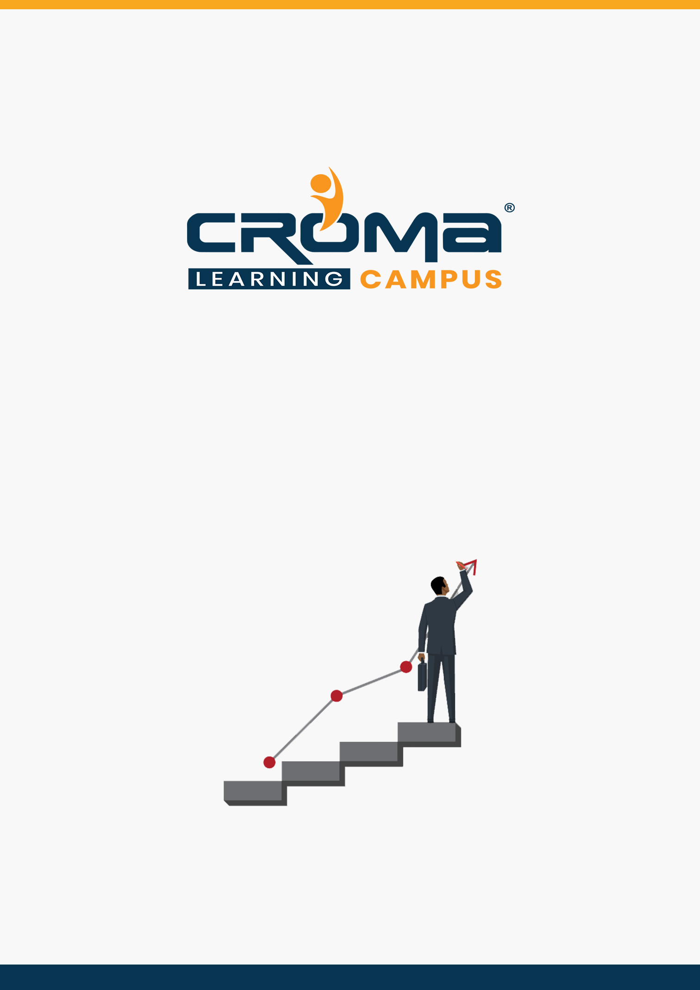

**SAP CRM Training Curriculum**

**STRUCTURE**

**www.cromacampus.com | helpdesk@cromacampus.com | +91-120-4155255**

**SAP CRM Training Curriculum**

*“Learn to gain deep customer insights and understand their entire journey efficiently and confidently.”*

**Course Objectives:**

* Get the comprehensive understanding of SAP CRM Module.
* Manage the entire customer life cycle efficiently and intelligently.
* Learn how to optimize key processes, leverage various analytics and reporting tools, and assess the performance.
* Prepare yourself for SAP CRM global certification exam and start applying for jobs.

**Course Description:**

In an environment where many companies have lost sight of the real meaning of customer relationship management (CRM), it's critical to remember what SAP CRM module is about. It's about acquiring and retaining customers, improving customer loyalty, gaining customer insight, and implementing customer-focused strategies. A true customer-centric enterprise helps your company drive new growth, maintain competitive agility, and attain operational excellence.

That's why SAP has introduced "CRM without compromise" We have listened to the needs of our customers - for rapid adoption and user productivity, quick time to value, and seamless, best-practice operations between front- and back-office. You can avoid CRM trade-offs with applications that are:

* **Simple** - Drive user uptake and effectiveness with an intuitive, Web-based user interface that's unified across our CRM solutions - delivering deep SAP CRM software capabilities uniquely tailored for business users.
* **Flexible -** Choose the right SAP CRM solution for the right situation with flexible deployment models that include on-premise, on-demand, and hybrid.
* **Comprehensive** - Provide an exceptional and consistent customer experience with front-office capabilities for all channels across marketing, sales, and service; embedded analytics; and end-to-end, industry-specific processes - delivered on the proven SAP NetWeaver platform.

**Course Content:**

**Module 1: SAP CRM Fundamentals**

* Overview of the SAP CRM application
  + Fundamentals and architecture
  + Overview of key areas (Marketing, Web Channel, Channel Management, Sales, Interaction Center, Service, Field Applications, Analytics, Implementation & Operation, Integration)
* CRM Basic Data Customization
  + Account Management
  + Organizational model
  + Product master
  + Customizing settings for each object
* CRM Business Transactions
  + Overview of generic functions in business transactions
  + Activity management
  + Customizing for these objects
  + Process Control and Determination
  + Partner determination
  + Actions
  + Overview of pricing in CRM
  + CRM billing
* CRM Middleware: basic concepts of CRM middleware, replication administration, data exchange, monitoring, and error handling
* User interface (UI) technology in SAP CRM

**Module 2: Customer Interaction Center Implementation**

* Architecture landscape
* Agent functions and processes in the IC
* Define CIC Profile and Customer-Specific
* Workspaces
* Define front-office framework
* Component Configuration
* Action Box Configuration
* CTI Configuration
* Client Implementation Case Study - Live Exercise

**Module 3: Internet Sales Implementation**

* Architecture and landscape
* Set up logical system and connection with OLTP R/3 and APO
* Configuration of the CRM Server - Base Customizing
* Configuration Web Application
* Creating Product Catalog
* Publication of Product Catalog content
* Create Internet User for order processing
* Sales Transactions using Internet Sales
* Web Shop Maintenance
* Client Implementation Case Study - Live Exercise

**Module 4: CRM Marketing Implementation**

* Opportunity Management
* Activity Management
* Marketing Planning and Campaign Management (Marketing Planner, Product Selection, Partner Functions, Generic Actions, Campaign Execution)
* Marketing Calendar
* Customer Segmentation
* External List Management

**Module 5: Placement Guide**

* Tips to clear an Interview
* Common Interview questions and answers
* SAP CRM Interview Questions and Answers
* Resume Building Guide
* Attempt for SAP CRM Global Certification Exam
* Start applying for Jobs